

Year 7 Science
Investigating Test

SECTION 1: MULTIPLE CHOICE (1 mark each)
Circle your answer on the multiple choice answer sheet.

- Which is the most important rule of the science laboratory?
  - Never run or muck around.
  - Do not eat or bring food into a science laboratory.
  - Wear appropriate footwear and clothing.
  - Always follow your teachers’ instructions.

- Which of these is false?
  - You should always wear closed in shoes in science laboratories.
  - You should always sit down when doing experiments.
  - You should never put broken glass in the bin.
  - You must report all accidents, spills or breakages to your teacher before cleaning them up.

- A chemical bottle has the following symbol on its label.
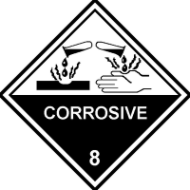

Which of the following is true?
  - The liquid must not be removed from the laboratory.
  - The liquid is corrosive and may burn you if it gets on your skin.
  - The liquid is safe to taste.
  - The liquid is flammable and may catch fire if used near a flame.

- What should you do if someone gets chemicals in their eye?
- Make them put safety glasses on.
- Wash their eyes out with water.
- Make them keep their eyes closed and cover with a bandage.
- Let them rub their eyes to make tears come.

- Which of these is most accurate to measure 50mL of water?
  - A beaker
  - A measuring cylinder.
  - A triple beam balance.
  - A conical flask.

- Apparatus means
- all the materials and equipment you will use for an experiment.
- the step-by-step instructions
- a drawing of your experiment.
- tables or graphs showing results

- When you light a Bunsen burner, you should
- turn on the gas tap, then light the match.
- make sure the air hole is open.
- check the hose for leaks first.
- place the lit match in the air hole.

- What colour is the safety flame for a Bunsen burner?
- blue
- green
- red
- yellow

- The independent (or experimental) variable is the factor in an experiment that is
  - changed deliberately to find its effect.
  - measured in the results.
  - kept the same for each part of the experiment, to make it a fair test.
  - unable to be controlled or kept the same.

- Which of the following can be put down the sink, at school or at home?
- cooking oil
- kerosene
- paint
- water

SEMESTER ONE 2023
Investigating Science Test:
ANSWER BOOKLET

NAME:
FORM: DATE:

Multiple Choice Short Answer Total

/10

/20

/30

SECTION ONE: Multiple choice answers
Cross (X) through the correct answer.

1 | a | b | c | d
2 | a | b | c | d
3 | a | b | c | d
4 | a | b | c | d
5 | a | b | c | d
6 | a | b | c | d
7 | a | b | c | d
8 | a | b | c | d
9 | a | b | c | d
10 | a | b | c | d

SECTION 2: Short Answer (20 marks)
Answer the questions in the spaces provided.
- Name these pieces of equipment (5)
a)  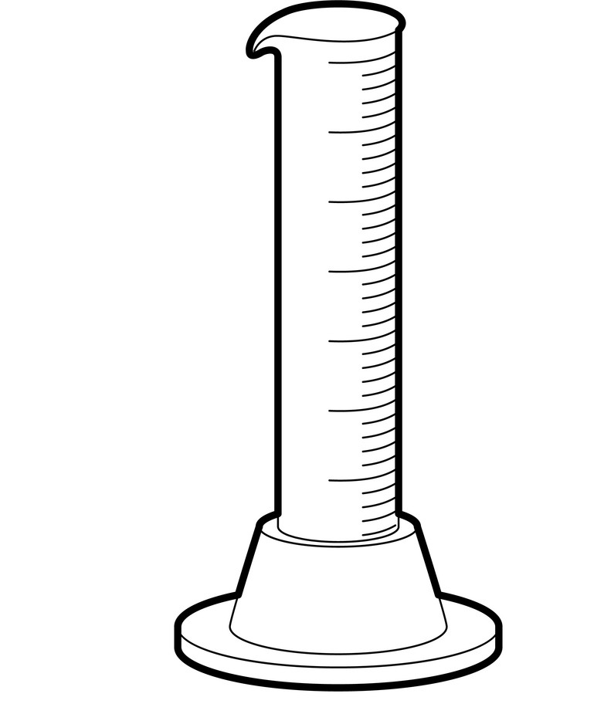  __________ | b)  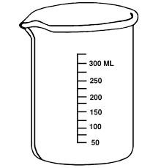  ____________ | c)    ___________ | d)  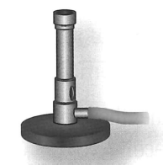  ___________ | e)  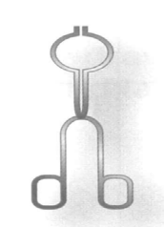  ____________
- Draw a scientific diagram for these pieces of equipment (5)

Equipment | Scientific diagram
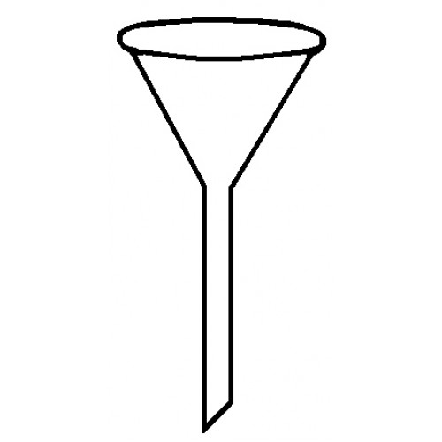
Filter funnel
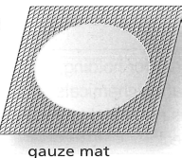

Gauze Mat
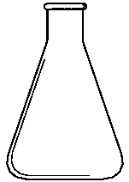
Conical flask
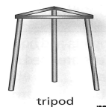

Tripod
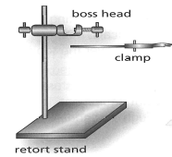

Retort Stand

- Write the lab report heading that matches each description (5)

- A statement that describes why the experiment is being done
___________________________________________________________
- Explains how to carry out the experiment
__________________________________________________________
- A record of data, using tables and graphs where possible
__________________________________________________________
- Analysis of the results and the method used
__________________________________________________________
- A statement that summarises the findings of the experiment
__________________________________________________________

4. Record the measurement for each of the following (5)

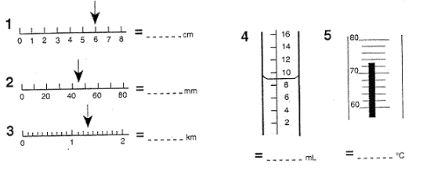

END OF TEST

